The COACH Trial
Comparing cochlear implants with hearing aids in adults with severe hearing loss

Participant Information Sheet
Version 1.3 20Apr2022
IRAS Project ID: 297574

- You are invited to take part in our research trial

- The COACH trial is looking to recruit adults with severe hearing loss who do not meet the NHS criteria for a cochlear implant but who are close to meeting those criteria. The trial will assess whether a cochlear implant or hearing aids are better at improving speech understanding for adults with severe hearing loss or if they are similar. We don’t know the answer and that is what the trial aims to find out.
- This information sheet is to help you understand why the research is being carried out and what it will involve if you decide to take part.
- Please take time to read this information and ask us if there is anything that is not clear or that you would like more information about. Discuss it with friends and family if you wish.
- It is entirely your decision whether to take part in this trial. If you agree to take part, you are free to withdraw from parts or all the trial at any time and without giving a reason. If you choose not to take part, your care will continue in the normal way.
- People with severe hearing loss have contributed to the design of this trial and some of the written materials.
- A summary of the trial
In the UK, the NHS offers cochlear implants to some people with severe or profound hearing losses who do not get enough benefit from their hearing aids. For these people, cochlear implants can improve their ability to recognise sounds and understand speech.

This trial aims to find out whether some adults who are not currently offered a cochlear implant on the NHS would benefit more from a cochlear implant than they would from using hearing aids alone. These people are those whose hearing or speech test results are just outside of the range that would make them eligible for a cochlear implant on the NHS. We do not yet know if cochlear implantation is a good treatment option, compared to hearing aids for these people.

In the trial, half of the people will receive a cochlear implant, and the other half will receive new hearing aids (or can choose to continue to wear their own). People will be put in one of the two groups at random (by a computer). Though we don’t know if either treatment might be better than the other, we know enough about the safety and potential benefits of both treatments to believe it is appropriate to offer either option to people in this trial. Before you are put into either group by the computer, a doctor will confirm that either treatment would be a safe and appropriate option for you.
After all trial data is collected from all people, we will compare how well the two groups can understand speech after 9 months.

If you are interested in taking part in this trial, you will be given many opportunities to discuss questions and concerns with the clinical and research teams before deciding whether to take part. Whichever group you are put into, you will be supported to make the best use of the hearing technology that is offered to you.

- What is the purpose of the trial?
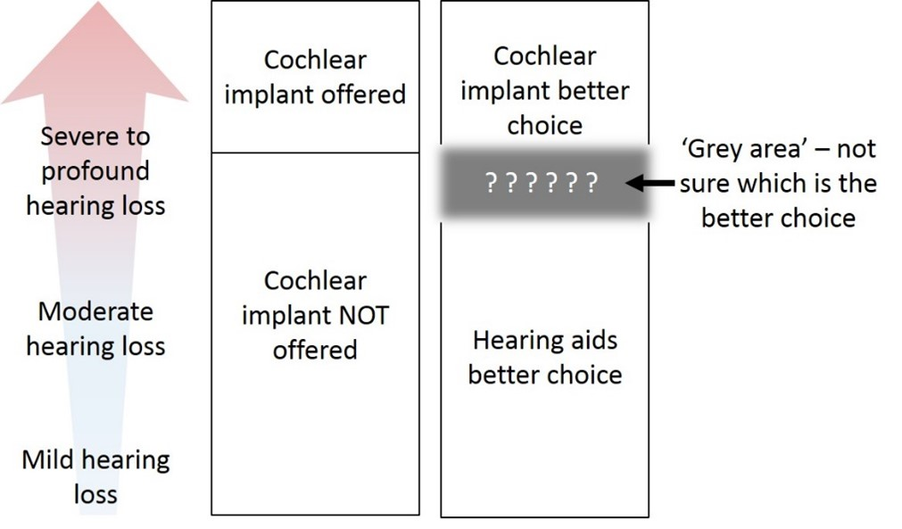
Currently, we do not know whether a cochlear implant is more effective than hearing aids in adults whose hearing test results and speech understanding scores are just outside the range that would make them eligible to receive a cochlear implant on the NHS. This is the ‘grey area’ that we are hoping this trial will provide an answer for, which could also influence current NHS policy and therefore offer the best treatment possible for all people in the future.
- Why have I been invited to take part?

You have been invited to consider taking part in this trial as we think you may be eligible. To be eligible, we will need to check your current level of hearing loss, how well you understand speech, and whether you are suitable for cochlear implant surgery. This trial plans to recruit a total of 130 people at up to 10 different NHS hospitals across the UK.
- Do I have to take part?

It is completely up to you whether or not you take part in the trial. Before you decide, it is important for you to understand why we are doing the trial and what it involves. Please take your time to read the following information carefully and talk to your friends, relatives and anyone else you feel is appropriate. We will explain the trial and answer any questions you may have. If you agree to take part, we will ask you to sign a consent form.
- What would taking part involve?

Taking part in this trial will be for up to 18 months and you would come into the clinic at least 6 times. Each research appointment will last between 1 hour – 90 minutes and will take place at your nearest or most convenient clinic. With your permission, we will tell your GP about you taking part in this trial.

Research visits are face to face appointments, but you will also sometimes need to communicate with the research team remotely. This contact can be done using any method of contact you prefer. This can include telephone, video calls (with captions) email, text message, or anything else you find works best for you. We will try to schedule the research visits at the same time as any hospital visits that are part of standard care to try to reduce the number of visits you will have.

All visits are explained below in the text and diagram:

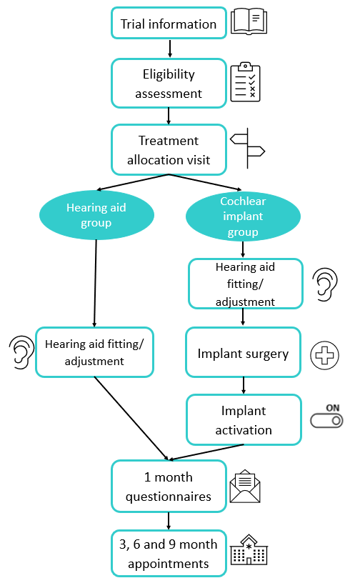
Finding out if you are suitable to take part in the trial (eligibility assessment):
If you are interested in taking part in the trial:
- You would complete an expression of interest form allowing us to perform some initial checks to see if you may be eligible for the trial.
- You will be contacted by a researcher to discuss the trial further.
- Following this, you may be invited to a face-to-face appointment, where we will tell you all about the trial and answer any questions you have.

If you are still interested in taking part, we will ask you to sign a consent form and start your trial eligibility checks, including a hearing test, speech tests and a hearing aid assessment. Signing this consent form does not mean you must take part in the trial, and you can change your mind at any point.

If you are still eligible after these first checks, you will then start the COACH eligibility pathway. This will include several appointments and will follow the same procedures that all patients being considered for a cochlear implant would receive at your clinic. These could vary between hospitals and is to ensure you are fit and well enough to receive a CI if that is the group you are allocated to. The researcher will explain to you what further visits you will have. One of these visits will include an MRI or CT scan to check that your inner ear (cochlear) is suitable for cochlear implantation. Other appointments also include counselling, to ensure that you understand the changes in your hearing that a cochlear implant may provide and what learning to hear with a cochlear implant involves, offer you support, give you the opportunity to ask questions, and ensure you would be happy to go ahead with surgery if you were offered a cochlear implant as part of the trial. Only people who are confirmed as both eligible for the trial and eligible for a cochlear implant after going through the COACH eligibility pathway would be invited for a treatment allocation appointment. If you are not eligible for the trial, your care will continue as normal under the NHS. The information collected up to this point will still be kept.
Treatment allocation appointment:
If you are eligible for the trial, you will be invited back for a treatment allocation appointment. The first thing we will do at this appointment is re-confirm you are still happy to continue taking part in the trial and answer any further questions you may have about what comes next.

If you are happy to continue, you will be asked to complete some hearing tests, speech tests and questionnaires These questionnaires will be about your hearing and overall health. This is the data that will be compared to all future questionnaires and tests you complete at 1, 3, 6 and 9 months.
At the end of the visit, the computer will randomly put you in one of the two groups (hearing aid group or cochlear implant group). You will have an equal chance of being in either group, like flipping a coin. This ensures there is a fair comparison between the two groups. Neither you, the clinical team nor the research team can choose which group you will be allocated to, as this could lead to the groups being unequal and the results of the trial being unreliable. We currently do not know which treatment will give better results which is why we need to compare the groups fairly.
Hearing aid group:
Hearing aid fitting/adjustment appointment:
If you are in this group, you will continue to use hearing aids in both ears and you will not receive a cochlear implant. The hearing aids offered as part of this trial are from the danalogic GN Ambio Smart range. The decision of which hearing aids you receive will be discussed between you and the clinical team. You will have the choice of being fitted with these state-of-the-art hearing aids, or you can opt to keep your current hearing aids. If you keep your current hearing aids, an audiologist will check to make sure they are set up in the best way for you. Fitting of the new hearing aids, or adjusting your current hearing aids, will happen within 3 months of your treatment allocation appointment.

Support:
You will be offered remote follow-on support within 1 week of your fitting/adjustment appointment to discuss and solve any initial difficulties you may have. Ongoing support will be provided throughout the whole trial, but if you have opted for new hearing aids, we will also take care of all repairs and replacements for up to 2 years after you receive the hearing aids. After the trial is finished, the new hearing aids are yours to keep, and you will continue with your normal NHS care.

Cochlear implant group:
If you are in this group, you will need to give consent for surgery. You will receive a cochlear implant in one ear and the clinical team will discuss the choice of ear to be implanted with you. However, they will decide which model of implant is most clinically appropriate for you.

Cochlear Implant Models included in the trial: Cochlear™ Nucleus® CI632, Cochlear™ Nucleus® CI622

If you would like to understand more about cochlear implants, there is a lot of information on the British Cochlear Implant Group website: www.bcig.org.uk.

Hearing aid fitting/adjustment appointment:
Prior to surgery you will be offered a new hearing aid for the ear that is not being implanted, or if you choose to keep your own hearing aid, we can make sure that this is set up in the best way for you. All other information about hearing aid fitting and maintenance is the same in this group as detailed above for the hearing aid group.

Implant surgery:
The cochlear implant surgery will take place within 3 months of your treatment allocation appointment. You will need an x-ray or CT scan to check the implant has been correctly inserted. You will usually be able to go home on the same day as your surgery, although in some cases (for example if your surgery is later in the day) an overnight stay may be required.. Following the surgery there is a wait before implant activation. During this time, you would not be able to use your hearing aid in the implanted ear. If you use a hearing aid in the other ear, you can use that during this time. Surgery will follow routine NHS practices and more information about it will be discussed with you by the clinical team during your appointments. There may be additional imaging as part of routine care.
Implant activation:
You will attend an appointment approximately 1 month after your surgery to turn the cochlear implant on. Your implant will be programmed for you over several appointments over the following weeks and months in line with your cochlear implant centre’s standard care.
There will be a choice of which sound processor (the external part of the cochlear implant) you can have, from the options which are included in the trial. The decision of which you receive will be discussed between yourself and the clinical team.
Sound Processor Models included in the trial: Cochlear™ Nucleus® 7, Cochlear™ Kanso® 2

Support:
It is important to know that learning to hear with a cochlear implant takes time and practice. It is very different to adapting to new hearing aids. Once your cochlear implant has been switched on, you will have access to the standard rehabilitation services your cochlear implant service provides. This will vary from site to site and may be offered in-person or online. Rehabilitation services may include any or all of the following: counselling about adapting to cochlear implant sound, listening practice exercises, communication tactics training, support groups, telephone training, and technology such as apps for listening practice and hardware such as remote microphones.
If you have a hearing aid for the non-implanted ear, you will also be offered the same hearing aid support as the hearing aid group, which is detailed above.

Follow-up:
All follow-up timepoints are scheduled from the time of hearing aid fitting/adjustment (hearing aid group) or when your cochlear implant was activated (cochlear implant group). Contact and appointments after hearing aid fitting/implant activation will be the same for both groups, as detailed below. If you are in the cochlear implant group, these research appointments will be in addition to your clinical cochlear implant rehabilitation appointments but will wherever possible these will be scheduled on the same day to limit your visits to clinic.
1-month: You will be sent a questionnaire booklet in the post. These will be the same questionnaires that you completed at your treatment allocation visit. They can be done in your own time.
3-, 6- and 9-months: At these appointments, an audiologist will test your hearing and ask you to complete the same speech tests and questionnaires as you did at your treatment allocation visit.
Monthly checks: On the months we aren’t seeing you in person, or posting questionnaires to you (months 2, 4, 5, 7, and 8) you will be contacted by a researcher to check how well your hearing aids/cochlear implants are working, how often you are using them and if you are having any problems.

Your travel expenses for each appointment will be paid for by us.
As a small token of our appreciation for your help, we will give you gift vouchers to thank you for taking part in the trial. Your completion of the trial is extremely valuable, and it is important that we have as many people as possible complete the questionnaires and attend all of the appointments.

Additional information about taking part:
Video recordings:
Video recordings will be made of you doing one of the speech tests during the trial. These recordings will take place on two occasions:
- Before you start your treatment (at the treatment allocation appointment)
- During your final 9-month follow up appointment
The videos will be taken head-on so that the type of hearing device(s) you are using cannot be seen. This is so that independent audiologists who do not know which group you are in can score the tests, making sure our trial results are fair. These recordings will be transferred digitally to the Nottingham Clinical Trials Unit and saved securely and confidentially with the rest of the trial data. The independent audiologists will only have access to these videos on secure databases, using password protected systems. Recordings will be stored for at least 7 years, after which your data will be disposed of securely and your confidentiality will be protected in line with the UK Data Protection Act.
Optional interviews:
A small group of people will also be asked to take part in interviews about their views of cochlear implantation. This is optional and will be covered by a separate information sheet. Written quotations from the interviews will be anonymised and may be used in publications and presentations.
Recruitment Study:
Researchers from the University of Nottingham would like to audio-record some of the conversations that healthcare professionals have with people about whether they want to take part in the COACH trial. This is to help us understand how this trial and the treatments are being explained to potential participants and if there are any improvements we can make. There is a separate information sheet to provide details about this. We would need your permission before audio-recording any conversations and it is entirely up to you if you are happy for these conversations to be recorded or not. It will not affect your participation in the trial.
- What are the possible benefits of taking part?

There is no guarantee that taking part in this trial will directly benefit you.
Both new hearing aids/adjusting your current hearing aids and cochlear implants may provide an improvement in your hearing, but it is not known if this will be the case. The information we collect from this trial may help us to improve treatment for people with hearing loss like yours in the future and help us understand the condition better. If you are in the cochlear implant group, you will receive a cochlear implant in one ear that would not be available to you on the NHS at the time of the trial, and you will have the option to use a new hearing aid in your other ear or have your current hearing aid adjusted. If you are in the hearing aid group, you will have the option to receive new state-of-the-art hearing aids or have your current hearing aids adjusted.
- What are the possible disadvantages and risks of taking part?

Both treatments in this trial are already available as standard NHS procedures but only for people who meet the current NHS eligibility criteria. Like any treatment, both have possible disadvantages and risks. If you are confirmed as eligible, then the clinical team involved in your treatment will have already decided that either treatment is a safe and suitable option for you and are happy for you to take part in this research. The trial will take up some of your time, as detailed above in section 6.

X-rays and scans for all participants in either CI or hearing aid groups:
As part of the checks to see if you are eligible for the trial, an MRI or CT scan may be carried out. After your cochlear implantation surgery, you will have a CT scan or X-ray. This is the same process as anyone receiving a cochlear implant on the NHS. There may be additional imaging as part of routine care. If you are pregnant before your cochlear implantation surgery, your participation in the trial will be paused and you will carry on taking part in the trial, if you still wish to, after birth. If you become pregnant after your cochlear implantation surgery, you will not have a CT scan or X-ray until you have given birth. If your doctor thinks a CT scan or X-ray is medically necessary while you are pregnant, special radiation protection measures will be taken.

These scans and X-rays are extra to those that you would have if you did not take part in the trial. X-rays and CT scans (but not MRI scans) use ionising radiation to form images of your body to provide your doctor with clinical information. Ionising radiation may cause cancer many years or decades after the exposure.

We are all at risk of developing cancer during our lifetime. Half the population is likely to develop one of the many forms of cancer at some stage during our lifetime. Taking part in this study will increase the chances of this happening to you to by a tiny amount, about 0.02%.

Cochlear implant group:
Risks of surgery
If you are allocated to receive a cochlear implant, you will have an in-depth discussion about the surgery and possible risks during your face-to-face appointments and you can ask any questions you may have at any time. These should be considered carefully by you. A common risk following surgery is the loss of much or all of the natural hearing you had in that ear before, meaning it would be extremely unlikely that you could go back to using a hearing aid on that side if you were not happy with the cochlear implant. Other risks following surgery may include: temporary facial weakness, tinnitus, meningitis, pain, and discomfort of the cochlear implant, as well as the normal risks associated with surgery and general anaesthesia. It is usual for someone having cochlear implant surgery to have two weeks off work to recover afterwards. Your clinical team will discuss these things with you in more detail prior to surgery as part of standard care. Please note that cochlear implant surgery is an irreversible procedure.

Impact on hearing and daily life
Learning to hear with a cochlear implant takes time and practice. You may find that for the first weeks and months you are hearing less well than you were before, until your brain adjusts to the new way of hearing. You can help this process by doing lots of listening exercises and practice which will be explained to you by the local CI team as part of the standard NHS post-implant care pathway. These things are likely to have more impact on your day-to-day life than adjusting to new hearing aids.

Hearing aid group:
If you are allocated to receive new hearing aids, the risks are the same for any new hearing aid and may include pain and discomfort from use of the new hearing aids, ear infections and worsening of eczema. This can be discussed further with your clinical team.

- What if there is a problem?

If you have concerns or questions about any aspect of this trial, you should ask to speak to the local researchers; their contact details are at the end of this information sheet. If you remain unhappy and wish to complain formally, you can do this through the NHS complaints procedure via your local Patient Advisory and Liaison Service (PALS) or equivalent <insert Local PALS details>.

In the event that something does go wrong, and you are harmed during the research, and this is due to someone’s negligence, then you may have grounds for a legal action for compensation, but you may have to pay your legal costs. The normal National Health Service complaints mechanisms will still be available to you.
If any questions remain you can contact the trial coordinating centre:
Tel: +44 (0)115 8231600, Email: COACH@nottingham.ac.uk
- What will happen if I don’t want to carry on with the trial?

If you begin the trial, but then decide that don’t want to carry on with any aspect of it, please talk to us as soon as possible but please note that CI surgery is an irreversible procedure. Your participation is voluntary, and you are free to withdraw at any time, without giving any reason and without your legal rights being affected but we would like to understand your reasons if possible. If enough people do not complete the trial, then we will not be able to find out whether cochlear implants are beneficial for people like you with similar levels of hearing loss. If you withdraw, we will no longer collect any information about you or from you, but we will keep the information about you that we have already obtained. We are not allowed to tamper with study records and this information may have already been used in some analyses and may still be used in the final study analyses. To safeguard your rights, we will use the minimum personally identifiable information possible.

If you are unhappy with any part of the trial, please discuss this with the research team and they can advise you on your options. Even if you withdraw completely, the information already collected will not be erased and this information may still be used in the trial analysis.

If you withdraw, your care will continue under the NHS and if you have received a CI, you will continue your ongoing care outside of the trial.
- How will information about me be used?
Researchers at the Nottingham Clinical Trials Unit (part of the University of Nottingham) will need to use information from you, your medical records and, in some cases, your GP or other NHS services for this research trial and any potential future follow up relating to this trial. This information will include your initials, date of birth, NHS number, name and contact details. The researchers will use this information to help them carry out the trial or to check your records to make sure that the research is being done properly. People who do not need to know who you are, will not be able to see your name, any identifiable details or contact details, and your data will have a code number instead.

If you are randomised to the cochlear implant group, some of your details will be shared with Cochlear Ltd™ because all cochlear implants must be registered with the manufacturer and linked to the named individual receiving it. This company will not know that you are taking part in the COACH trial, just that you have received one of their cochlear implants (like any other patient). All information about you will be kept safe and secure.

Once the trial has finished, the data will be kept so the results can be checked and you can be told what happened in the trial (unless you tell us you do not want to know). Reports will be written in a way so that no-one can work out who took part in the trial. For more information about how your information will be stored, please see page 8.
- What are your choices about how your information is used?

You can stop being part of the trial at any time, without giving a reason, but we will keep information about you that we have already collected up to that point. If you choose to stop taking part in the trial, we would like to continue collecting information about your health relating to the trial treatment from your GP until the end of the trial. If you do not want this to happen, tell us using the contact details in section 18 and we will stop. We may also use data we collect in this trial for future research. After at least 7 years the data collected during the trial will be disposed of securely. If you give us your permission, we may keep your contact details so we can get in touch if there is any relevant future research to do with your hearing loss that you may be interested in taking part in. If you do not wish for your contact details to be kept be contacted about future research, these will also be disposed of securely at the end of the trial. These options are available on the trial consent form.

For more information about your rights involving your data, please see the University of Nottingham Privacy Notice which explains how your personal data is processed and the rights you have with respect to your personal information: https://www.nottingham.ac.uk/utilities/privacy/privacy.aspx.
- Will my GP be notified?
With your permission, we will inform your GP that you are taking part in this trial. The identifiable information shared with your GP will be used to provide any additional data about your health status that the clinical team are not able to get hold of.

- Where can you find out more about how your information is used?

You can find out more about how we use your information:
- at www.hra.nhs.uk/information-about-patients/ and www.hra.nhs.uk/patientdataandresearch
- at the link above in section 12
- by asking one of the research team
- by sending an email to COACH@nottingham.ac.uk
- by calling the Nottingham Clinical Trials Unit on +44 (0)115 8231600
- Who is organising and funding this trial? How has it been approved?

The COACH trial is being organised by Nottingham Clinical Trials Unit (NCTU) as part of the University of Nottingham (the Sponsor). The trial is being paid for by Cochlear Ltd™ - a company who make cochlear implants and who will be providing both the cochlear implants and the hearing aids for the trial. They will not be involved in the running of the trial or have any involvement in analysing the results.

All research in the NHS is reviewed by an independent group of people, called a Research Ethics Committee, to protect your interests. This trial has been reviewed and approved by South West – Frenchay Research Ethics Committee.

A selection of the general public who have previously been treated for hearing loss and have received a cochlear implant or who wear hearing aids have helped us to plan and design this trial. These representatives are also involved in the teams that oversee the running of the trial.
- What if relevant new information becomes available?

Sometimes we get new information about the treatments that are being tested during a trial. If this happens, your clinical team will tell you about any new information and discuss this with you.

Please note that cochlear implant surgery is an irreversible procedure, but we will contact you with any new information and the choices available to you. If you decide to continue in the trial, you may be asked to sign a new consent form.

If you are in the hearing aid arm and during the trial you become eligible for a cochlear implant under the current NHS criteria, then you will be informed of this. You could choose to start the COACH eligibility pathway (see section 6 above) on the NHS while still participating in the trial. If you were offered a cochlear implant on the NHS before the end of the trial period you would be free to choose whether to complete the trial, or to leave the trial early to receive a cochlear implant. Your decision whether or not to continue in the trial would in no way affect your clinical care.
- What happens at the end of the trial?

When the trial ends for you, your healthcare will continue as normal. For up to 2 years after receiving your new hearing aids and/or cochlear implant, ongoing support will be provided for adjustments or repairs. After this period, your care will continue under the NHS. At the end of the trial, we will review and analyse all the data collected, and the results will be published in scientific medical journals and presented at conferences. You will not be identified in any publication. We will send you a newsletter with a summary of the trial results unless you ask us not to.

The anonymised results will be shared with government departments so that they will have better information on which to base their guidance for which adults in the UK should be offered cochlear implantation. The results will also be shared with hearing care professionals across the public and private sectors, via professional bodies, international conferences, and scientific publications. In this way, we hope the results will help adults with severe hearing loss receive the best possible care. This is the first randomised clinical trial of cochlear implants for adults with severe hearing loss, and so the results will be internationally relevant, and could optimise the provision of hearing aids and cochlear implants around the world.
- COVID-19 Safety Measures
Due to the COVID-19 pandemic, the number of face-to-face appointments was reduced as much as possible. The following adjustments to the trial can be made for your safety. These will depend on local and national guidelines at the time you are taking part in the trial. These may change throughout the duration of the trial:
- Where face-to-face appointments are necessary, social distancing and face coverings may be mandatory, dependent on the best practice at each hospital site at the time of your appointments.
- The research team may be wearing personal protective equipment (PPE) during the visits. This would include a clear face visor or mask, worn so that lip reading is possible.
- For those undergoing cochlear implantation surgery, it is possible that a negative COVID-19 test will need to be provided prior to surgery as per the <insert NHS hospital name> protocol.
- For further information and guidance, please visit <insert website link to NHS trust COVID policy>.
- How to contact us

Contact details of your local care team:
<Sites to enter name, address, email address, telephone numbers of PI and research team including the 24-hour emergency contact number>

- Where to find us

Location and transport details of your local trial site:
By car
<sites to add postcode and street name, where nearest car parking is and the costs, are disabled spaces available>
By bus
<sites to add where to get bus times from (transport website and telephone number)>
By tram
<sites to add details here if relevant such as nearest stops and tram website>
By train
<sites to add details here if relevant such as nearest train station, train website, taxi rank, connecting bus>
On arrival
<sites to add directions once at your premises such as disabled access to the building, reception telephone number>
Additional information on how your information will be stored
We will follow ethical and legal practice and all information about you will be handled in confidence.
If you join the study, we will use information collected from you and your medical records during the course of the research. This information will be kept strictly confidential, stored in a secure and locked office, and on a password protected database at the University of Nottingham. Under UK Data Protection laws the University is the Data Controller (legally responsible for the data security) and the Chief Investigator of this study (named above) is the Data Custodian (manages access to the data). This means we are responsible for looking after your information and using it properly. Your rights to access, change or move your information are limited as we need to manage your information in specific ways to comply with certain laws and for the research to be reliable and accurate. To safeguard your rights we will use the minimum personally – identifiable information possible.
You can find out more about how we use your information and to read our privacy notice at:
https://www.nottingham.ac.uk/utilities/privacy.aspx.
The data collected for the study will be looked at and stored by authorised persons from the University of Nottingham who are organising the research. They may also be looked at by authorised people from regulatory organisations to check that the study is being carried out correctly. All will have a duty of confidentiality to you as a research participant and we will do our best to meet this duty.
Where possible, information about you which leaves the NHS clinic will have your name and address removed and a unique code will be used so that you cannot be recognised from it, however sometimes we need to ensure that we can recognise you to link the research data with your medical records so in these instances we will need to know your name and date of birth. We will also need this information if we need to follow up your medical records as part of the research, where we may need to ask the Government services that hold medical information about you (such as NHS Digital, the Office for National Statistics, among others) to provide this information to us. By signing the consent form you agree to the above.
Your contact information will be kept by the University of Nottingham for up to 7 years after the end of the study so that we are able to contact you about the findings of the study and possible follow-up studies (unless you advise us that you do not wish to be contacted). This information will be kept separately from the research data collected and only those who need to will have access to it. All other data (research data) will be kept securely for 7 years. After this time your data will be disposed of securely. During this time all precautions will be taken by all those involved to maintain your confidentiality, only members of the research team given permission by the data custodian will have access to your personal data.
In accordance with the University of Nottingham’s, the Government’s and our funders’ policies we may share our research data with researchers in other Universities and organisations, including those in other countries, for research in health and social care. Sharing research data is important to allow peer scrutiny, re-use (and therefore avoiding duplication of research) and to understand the bigger picture in particular areas of research. Data sharing in this way is usually anonymised (so that you could not be identified) but if we need to share identifiable information we will seek your consent for this and ensure it is secure. You will be made aware then if the data is to be shared with countries whose data protection laws differ to those of the UK and how we will protect your confidentiality.

