The COACH Trial
Comparing cochlear implants with hearing aids in adults with severe hearing loss

Short Participant Information Sheet
Version 1.3 20Apr2022
IRAS Project ID: 297574
- A reminder about the trial now you have been confirmed as eligible
This trial aims to find out whether some adults who are not currently offered a cochlear implant on the NHS would benefit more from a cochlear implant than they would from using hearing aids alone. These people are those whose hearing or speech test results are just outside of the range that would make them eligible for a cochlear implant on the NHS. We don’t know the answer and that is what the trial aims to find out.

In the trial, half of the people will receive a cochlear implant, and the other half will receive new hearing aids (or can choose to continue to wear their own). People will be randomly assigned (by a computer) to one of the two groups. After all trial data is collected from all people, we will compare how well the two groups can understand speech after 9 months.

Though we don’t know if either treatment might be better than the other, we know enough about the safety and potential benefits of both treatments to believe it is appropriate to offer either option to people in this trial. Whatever group you are randomly put in by the computer, we have confirmed through our eligibility assessments that either treatment would be a safe and appropriate option for you.
It is completely up to you whether or not you take part in the trial. Whichever group you are allocated to, you will be supported to make the best use of the hearing technology that is offered to you. As you will have 50% chance of being in either group, please take the time to read the information below to be sure that you would be happy to be part of either group.

For more information on the COACH trial, please refer back to the full Participant Information Sheet you have been given previously. Please contact your local research team using the contact details at the bottom of this sheet if you require a new copy.

- What would taking part involve?

Each research appointment will last between 1 hour – 90 minutes and will take place at the same clinic as your eligibility assessment appointments.

Research visits are face to face appointments, but you will also sometimes need to communicate with the research team remotely. This contact can be done using any method of contact you prefer. This can include telephone, video calls (with closed captions) using your preferred app, email, text message, or anything else you find works best for you.

All further visits are explained in the diagram and text below:

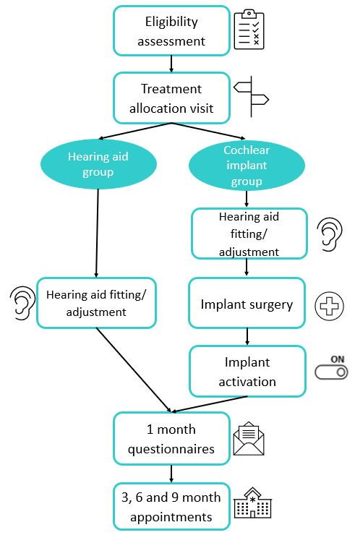
Eligibility assessment: You have now completed all the eligibility assessment checks and been confirmed as eligible to continue in the trial.
Treatment allocation appointment: The first thing we will do at this appointment is re-confirm you are still happy to continue taking part in the trial and answer any further questions you may have about what comes next.
If you are happy to continue, you will be asked to complete some hearing tests, speech tests and questionnaires. These questionnaires will be about your hearing and overall health. This is the data that will be compared to all future questionnaires and tests you complete at 1, 3, 6 and 9 months.
At the end of the visit, the computer will randomly put you in one of the two groups (hearing aid group or cochlear implant group). You will have an equal chance of being in either group, like flipping a coin. This ensures there is a fair comparison between the two groups. Neither you, the clinical team nor the research team can choose which group you will be allocated to, as this could lead to the groups being unequal and the results of the trial being unreliable. We currently do not know which treatment will give better results which is why we need to compare the groups fairly.
Hearing aid group:
Hearing aid fitting/adjustment appointment: If you are in this group, you will continue to use hearing aids in both ears and you will not receive a cochlear implant. The hearing aids offered as part of this trial are the Ambio Smart range. The decision of which hearing aids you receive will be discussed between you and the clinical team. You will have the choice of being fitted with these state-of-the-art hearing aids, or you can opt to keep your current hearing aids. If you keep your current hearing aids, an audiologist will check to make sure they are set up in the best way for you. Fitting of the new hearing aids, or adjusting your current hearing aids, will happen within 3 months of your treatment allocation appointment.

Support: You will be offered follow-on support within 1 week of your fitting/adjustment appointment to discuss and solve any initial difficulties you may have. Ongoing support will be provided throughout the whole trial, but if you have opted for new hearing aids, we will also take care of all repairs and replacements for up to 2 years after you receive the hearing aids. After the trial is finished, the new hearing aids are yours to keep, and you will continue with your normal NHS care.

Cochlear implant group:
If you are in this group, you will need to give consent for surgery. You will receive a cochlear implant in one ear and the clinical team will discuss the choice of ear to be implanted with you. However, they will decide which model of implant is most clinically appropriate for you.

Cochlear Implant Models included in the trial: Cochlear™ Nucleus® CI632, Cochlear™ Nucleus® CI622

Hearing aid fitting/adjustment appointment: Prior to surgery you will be offered a new hearing aid for the ear that is not being implanted, or if you choose to keep your own hearing aid, we can make sure that this is set up in the best way for you. All other information about hearing aid fitting and maintenance is the same in this group as detailed above for the hearing aid group.

Implant surgery: The cochlear implant surgery will take place within 3 months of your treatment allocation appointment. You will usually be able to go home on the same day as your surgery, although in some cases (for example if your surgery is later in the day) an overnight stay may be required. You will need an x-ray or scan to check the implant has been correctly inserted. Following the surgery there is a wait before implant activation. During this time, you would not be able to use your hearing aid in the implanted ear. If you use a hearing aid in the other ear, you can use that during this time. The surgery will follow routine NHS practices and more information about the surgery will be discussed with you by the clinical team during your appointments. There may be additional imaging as part of routine care.
Implant activation: You will attend an appointment approximately 1 month after your surgery to turn the cochlear implant on. The settings of your speech processor will be programmed for you over several appointments over the following weeks and months in line with your cochlear implant centre’s standard care.
There will be a choice of which sound processor (the external part of the cochlear implant) you can have, from the options which are included in the trial. The decision of which you receive will be discussed between yourself and the clinical team.
Sound Processor Models included in the trial: Cochlear™ Nucleus® 7, Cochlear™ Kanso® 2

Support: It is important to know that learning to hear with a cochlear implant takes time and practice. It is very different to adapting to new hearing aids. Following activation of your cochlear implant, you will have access to the standard rehabilitation services your cochlear implant service provides. This will vary from site to site and may be offered in person or online. Rehabilitation services may include any or all of the following: counselling about adapting to cochlear implant sound, listening practice exercises, communication tactics training, support groups, telephone training, and technology such as apps for listening practice and hardware such as remote microphones.
You will also be offered the same hearing aid support as the hearing aid group, which is detailed above.

Follow-up: All follow-up timepoints are scheduled from the time of hearing aid fitting/adjustment (hearing aid group) or when your cochlear implant was activated (cochlear implant group). Contact and appointments after hearing aid fitting/implant activation will be the same for both groups, as detailed below. If you are in the cochlear implant group, these research appointments will be in addition to your clinical cochlear implant rehabilitation appointments but will wherever possible these will be scheduled on the same day to limit your visits to clinic.
1-month: You will be sent a questionnaire booklet in the post. These will be the same questionnaires that you completed at your treatment allocation visit. They can be completed in more than one sitting in your own time.
3-, 6- and 9-months: At these appointments, an audiologist will test your hearing and ask you to complete the same speech tests and questionnaires as you did at your treatment allocation visit.
Monthly checks: On the months we aren’t seeing you in person for a visit, or posting questionnaires to you (months 2, 4, 5, 7, and 8) you will be contacted by a researcher to check how well your devices are working, how often you are using them and if you are having any problems.

Your travel expenses for each appointment will be paid for by us.
As a small token of our appreciation for your help, we will give you gift vouchers to thank you for taking part in the trial. Your completion of the trial is extremely valuable, and it is important that we have as many people as possible complete the questionnaires and attend all of the appointments.

Additional information about taking part:
Recordings:
Video recordings will be made of one of the speech tests during the trial. These recordings will take place on two occasions:
- Before you start your treatment (at the treatment allocation appointment)
- During your final 9-month follow up appointment
The videos will be taken head-on so that the type of device(s) you are using cannot be seen. This is so that independent audiologists who do not know which group you are in can and score the tests, making sure our trial results are fair. These recordings will be transferred digitally to the Nottingham Clinical Trials Unit and saved securely and confidentially with the rest of the trial data. The independent audiologists will only have access to these videos on secure databases, using password protected systems. Your confidentiality will be protected.

Optional interviews:
A small group of people will also be asked to take part in interviews about their experiences of being involved in the trial. This is optional and will be covered by a separate information sheet. Written quotations from the interviews will be anonymised and may be used in publications and presentations.

- What are the possible risks of taking part?

Both treatments in this trial are already available as standard NHS procedures but only for people who meet the current NHS eligibility criteria. Like any treatment, both have possible risks, but your clinical team have already decided that either treatment is a safe and suitable option for you.
If you are allocated to receive a cochlear implant, some risks following surgery may include: potential loss of the natural hearing you had before (meaning that you might not be able to go back to using a hearing aid if you were not happy with the cochlear implant), temporary facial weakness, tinnitus, meningitis, pain, and discomfort of the cochlear implant, as well as the normal risks associated with surgery and general anaesthesia. Your clinical team will discuss these things with you in more detail prior to surgery as part of standard care.
If you are allocated to receive new hearing aids, the risks are the same for any new hearing aid and may include pain and discomfort from use of the new hearing aids, ear infections and exacerbation of eczema. This can be discussed further with your clinical team.
- What will happen if I don’t want to carry on with the trial?

If you decide that you don’t want to carry on with any aspect of the trial, please talk to us as soon as possible. You are free to withdraw at any time, without giving any reason and without your legal rights being affected but we would like to understand your reasons if possible. If enough people do not complete the trial, then we will not be able to find out whether cochlear implants are beneficial for people like you with similar levels of hearing loss.

If you are unhappy with any part of the trial, please discuss this with the research team and they can advise you on your options. Even if you withdraw completely, the information already collected will not be erased and this information may still be used in the trial analysis.
- How to contact us

Contact details of your local care team:
<Sites to enter name, address, email address, telephone numbers of PI and research team including the 24-hour emergency contact number>

